Press Release
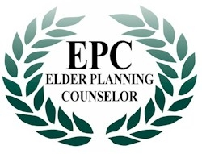

Contact: <Your Name> <Your Phone Number> or you@yourmail.com

LOCAL INTEREST

<Your Name> Qualifies as Charter Member
Of “Elder Planning Counselor” Program

TORONTO, ON – A nationally recognized designation, was conferred on <insert your name> after successfully completing an intense and rigorous test of knowledge regarding current seniors issues. The “Canadian Initiative for Elder Planning Studies” (CIEPS) course was established as a standard of service to seniors for all professionals and business people in providing seniors with high quality services and products that best suit their lives and circumstances. The “Elder Planning Counselor” (EPC) designation will immediately help seniors identify the business people and professionals who have a special interest and proficiency in dealing with them and their needs.

“Studies show that seniors want advisors who understand their life issues, alternatives and concerns, which respect their circumstances and experiences and can accommodate their physical and health needs. The EPC is the Canadian professional development standard for elder education,” says Thomas Miller, President of CIEPS.

Achieving this designation is a distinguished career milestone, attained only by those who have demonstrated proficiency in all relevant programs about seniors issues, including aging, health issues, financial planning considerations, long term care as well as end of life issues. This makes the “EPC” graduate a valued counselor to seniors, regardless of the service or product they provide.

The Elder Planning Counselor educational program has been designed by Canadians for Canadian Professionals.

For further information visit www.elderplanningcounselor.com

-30-

